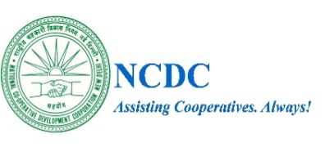 | राष्ट्रीय सहकारी विकास निगम  NATIONAL COOPERATIVE DEVELOPMENT CORPORATION  (An ISO-9001:2015 Certified Organization)  A Statutory Corporation Under the Ministry of Agriculture & Farmers Welfare, Government of India  (क्षेत्रीय कार्यालय, पुणे )  (Regional Directorate, Pune)
Tel.No. 020-26127049  Fax No:020-26128027  E-mail: ro.pune@ncdc.in | 5, B.J. Road,  Pune- 411001,  Website: www.ncdc.in
CORRIGENDUM TO E-AUCTION SALE NOTICE UNDER SARFAESI ACT,2002
This Corrigendum is being issued with reference to the E-Auction Sale Notice published by NCDC on 11th June 2026, regarding the sale of secured assets of Loknayak Jayprakash Narayan Shetkari Sahakari Soot Girni Limited, Kamalnagar, Untawad-Hol, Taluka Shahada, District Nandurbar, Maharashtra – 425 409, under the provisions of the SARFAESI Act, 2002.
This is to inform all concerned that in the E-Auction Notice published earlier, the Present Outstanding Balance as on 11.06.2026 was inadvertently mentioned as Rs. 14,84,82,074/- (Rupees Fourteen Crore Eighty-Four Lakh Eighty-Two Thousand Seventy-Four Only) due to a typographical error.
The correct Present Outstanding Balance as on 11.06.2026 is and should be read as:
Rs. 1,48,48,20,274/- (Rupees One Hundred Forty-Eight Crore Forty-Eight Lakh Twenty Thousand Two Hundred Seventy-Four Only).
All intending purchasers, bidders, and other concerned persons are requested to take note of the above correction.
All other lerms & conditions of the sale notice shall remain unchanged. This Corrigendum should be read together with the original e-auction sale notice and treated as one composite notice for all legal and procedural purposes

(Shri. Girraj Agnihotri)
Date: 08/07/2026 Authorised Officer
Place: Pune under SARFAESI Act, 2002
National Cooperative Development Corporation

